Effects of Sound on the Marine Environment

Demo Quick Start Guide

01 June 2012

# Introduction

ESME is an ONR Life Sciences Research Program focused on producing an integrated computer model of animal response to the sound fields produced by human activities, with a special emphasis on naval sound sources such as sonars, explosives, and acoustic communications.

This is a public demo of the acoustic simulation engine section of ESME. It allows you to create, edit, and explore ocean environments across the globe and visualize and analyze the transmission of sound underwater.

## Installation

ESME Workbench can be installed by downloading the latest version from <http://esme.bu.edu/download> . The installer will install the Workbench and a default set of environmental databases. Installed size is approximately 1.8GB.

## Getting Started

Having successfully installed the ESME Workbench and all associated Environmental Databases, navigate to the ESME Workbench icon in the Start Menu, and launch ESME.

The first time ESME runs, a wizard will run to help you configure some default locations. Select “Yes”. A progress window will display over the main UI:

|  |  |
| --- | --- |
|  |  |

This will create six sample locations, each with one acoustic source, and four types of environmental data, at various interesting locations along the coastal United States. Each of these locations, in turn, contains sound propagations to visualize.

Once up and running, more locations, scenarios, and sound sources can be created and interacted with.

# A Brief Example

The configuration wizard has created a collection of pre-computed examples for browsing and exploration. To get a feel for how ESME works, let’s open a location and its associated scenario, and then visualize the sound propagation at a particular location in that part of the ocean.

#### Opening a Location

|  |  |
| --- | --- |
|  | First, locate the Southern California item in the Locations pane located on the lower left hand side of the application window. Right-click on “Southern California” and select “Zoom to Location”. This will re-center the map display to the southern coast, and zoom in to the boundary of the location. The checkbox next to each location toggles the display of its boundary on the map. |

#### Opening a Scenario

|  |  |
| --- | --- |
|  | Expand the Southern California tree by clicking on the arrow expander on the left side of its name. Expand Scenarios, select “Southern California Sample”, right click, and select “Open this Scenario”. The Scenario sidebar, located above the Location sidebar, will populate with items. |

#### Viewing Environmental Data

|  |  |
| --- | --- |
|  | Next, inside the Scenario sidebar, expand the Environment tree. Check the environmental data type to be visualized on the map, and it will display. Mouse over the map itself and look in the tray on the bottom of ESMEs window to see detailed information about each environmental data type.  Double click on the map to see a graph of the sound speed profile at that point of the ocean. |

|  |  |
| --- | --- |
|  | The map display will update with the visualized environmental data. Here, bathymetry is shown. Wind speed, the location of each sound speed point, and bottom sediment type are all also available. |

#### Viewing a transmission loss

|  |  |
| --- | --- |
|  | In the Scenario sidebar, expand the Analysis Points tree, and double-click on the analysis point inside. The transmission loss viewer will appear. |

|  |  |
| --- | --- |
|  | Using the slider near the bottom of the transmission loss viewer, scroll through each directional slices in the analysis point. Click and drag on the color bar to adjust the displayed scale.  From here, the displayed transmission loss radial can be saved to disc as an image or CSV file. |

|  |  |
| --- | --- |
|  | By default, the color bar scale is relative to the minimum and maximum value of the transmission loss at that analysis point; double-click to reset the scale to be relative to the current radial of that transmission loss’ values. |

This brief tour should introduce many interesting concepts and means of interaction with preexisting data.

In the remainder of this Quick Start Guide, the user interface and the data it controls will be discussed in greater detail.

# ESME Workbench in More Depth

A few concepts are fundamental to ESME.

* A **Location** is an area of the ocean that has a specified **Bounding Box** and a **Name**.
* A **Scenario** is set in a **Location** during a **Time Period.**  It is a collection of one or more acoustic **Modes** of an acoustic **Source** that is associated with a **Platform**, as well as **Environmental Data** at a specific data **Resolution** associated with that Location and Time Period.
* An **Analysis Point** is a collection of the calculated sound propagation data for one or more modes. These are collectively called **Transmission Losses**, and model the complex interaction between an acoustic source and its underwater environment.

Once one or more modes are present, the transmission losses are calculated with Bellhop, a highly efficient acoustic ray-tracer provided by HLS Research.

## The Main Graphical User Interface

Similarly to many common GIS and mapping applications, interaction with ESME is mostly accomplished by interacting directly with the map itself, or by interacting with the tree control on the left-hand side of the window. This is further divided into two main panes: the **Location Pane** and the **Scenario Pane**.

### The Location Pane

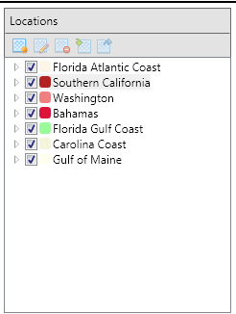 The Location Pane displays the currently configured Locations, and provides the primary way to:

* Create a new location
* Delete a selected location
* Edit the properties of a location

The buttons at the top of the pane all have tooltips that explain their respective functions.

Each location has a checkbox, which toggles the display of its bounding box on the world map. Clicking on the colored rectangle next to each location name lets the color and weight of the bounding box be customized.

Right clicking on the location name lets you zoom the world map to the bounds of that location, as well as other interactions.

Drilling down into each location exposes a hierarchy of data associated with that location:

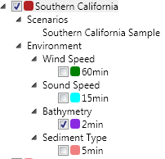

* The Environmental Data associated with the Location are shown. Each layer can be visualized separately on the map by clicking its checkbox.
* Each Location can be selected, viewed, or deleted through a context menu.
* The Scenarios that are associated with the Location are shown. Right clicking on one allows it to be loaded or modified. The scenario creator can be accessed through this context menu, preconfigured with the selected Location.

### The Scenario Pane

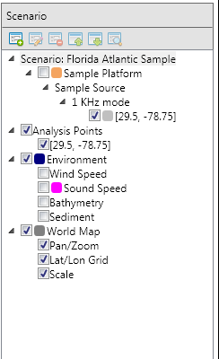The Scenario Pane displays all relevant information about acoustic sources operating in a particular Location, and is the primary way to:

* Create new scenarios
  + Top buttons or context menu on the Scenario tree
* Add, remove, or modify acoustic emitters
  + Context menus on Scenarios, Platforms, Sources, Modes.
  + F2 or double-click to rename
  + Select Properties dialog to modify acoustic parameters.
* Modify or delete previously calculated transmission losses
  + Context menu delete function
* Draw or hide visualizable data on the map
* Context menus on drawable items allow layer order to be moved
  + Checkboxes next to drawable items toggle display status
* View, save, and interact with transmission loss raytraces

### The Map

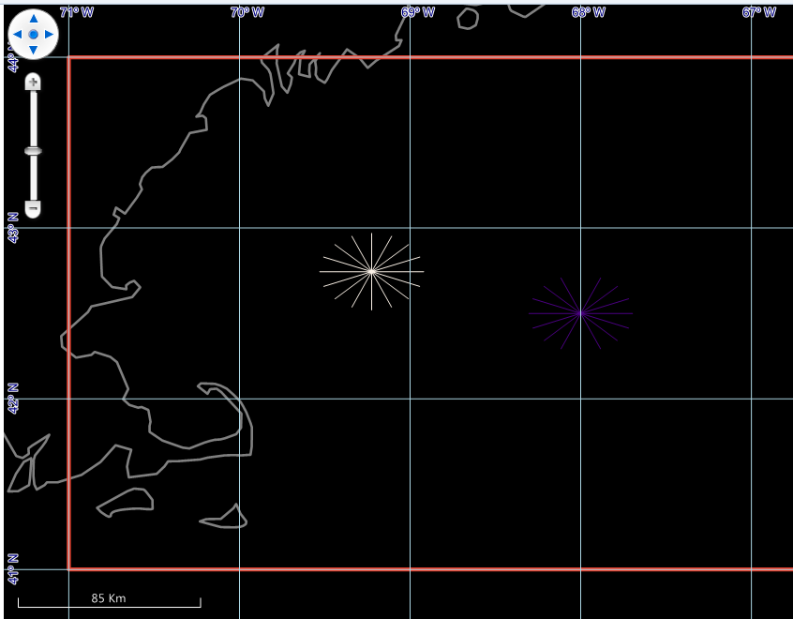

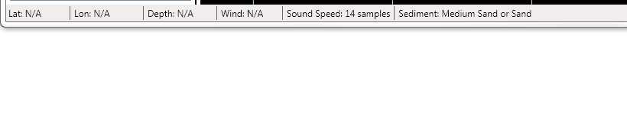

The Map displays currently selected geographic areas and environmental and experimental data. Here, two analysis points are shown off the coast of Massachusetts with no displayed environmental data. A status bar at the bottom of the application window shows detailed information for each data point, and updates as the cursor is moved.

For latitudes and longitudes that have data, the depth is displayed in meters, the wind speed in meters per second, the resolution of the sound speed calculation at that location, and the type of sediment at that location.

### Manipulation of Data Layers

#### Layer Display Order

When displaying multiple data layers at once – for example, both a collection of analysis points and bathymetric data – it is usually necessary to re-arrange the order in which these layers are displayed, as they are all completely opaque and will obscure layers shown under them.

|  |  |
| --- | --- |
|  | A series of options are available in the context menu of any visualizable item in the Scenario or Locations panel to accomplish this. Items can be moved forward or back in the display order, as well as displayed on top of everything, or sent to the very bottom. |

#### Layer Color

|  |  |
| --- | --- |
|  | Items listed in the tree control with a colored rectangle next to them can have different displayed colors and line weights. Currently Modes, the World Map, the Environment bounding box, and Platforms can all have custom colors.  Colors are randomly assigned for each layer type on creation, but can be freely adjusted.  To change the color of the layer in question, drill down in the selected Scenario or Location to the layer in question, and left-click on the colored square next to its name. A color selector dialog will let you adjust the color and the line weight.  These changes will persist and reappear the next time the Scenario is loaded. |
|  |

#### Sound Speed Visualization

The speed of sound in salt water varies as a function of salinity, temperature, and pressure. Double-clicking on the map anywhere within the Location boundaries displays the sound speed profile at that location, calculated using the most appropriate environmental data.

|  |  |
| --- | --- |
|  | The sound speed display window updates when a new location on the map is double-clicked.  The sound speed profile can be either copied to the clipboard or saved as an image or CSV file. |

# Location Interaction

Locations drive the rest of ESME. Without them, no scenarios may be created, no transmission losses calculated, and no other actions taken.

## Location Creation

To start creating a location, select the “New Location” button on the Location Pane

|  |  |
| --- | --- |
|  | This will launch the location creation tool, which is a combination of a map interaction element and a dialog box.  The map element is a large blue rectangle, which can be positioned anywhere on the map.  The dialog box is a simple selector displaying the four corners of the selected area and a name. |

|  |  |
| --- | --- |
|  | In this example, a location that encompasses approximately half of Cuba, all of Haiti and the Dominican Republic, the Bahamas, Jamaica, Puerto Rico, and assorted other Caribbean islands is selected. Once a name has been entered into the creation dialog box, the OK button becomes clickable, and this area will be added to the database of currently defined Locations. |

|  |  |
| --- | --- |
|  | That’s it! The location is added to the database, and appears in the Locations Panel in the main application window. |

## Scenario Creation

To start creating a Scenario, either click the “New Scenario” button in the Scenario Pane, or select “New Scenario” from the context menu of the Location in the Location Pane that you wish to use.

|  |  |
| --- | --- |
|  | If the scenario creator is launched from the scenario pane, a scenario may be created in any current Location.  If the scenario creator is launched from a Location’s context menu, it will be created in that location. |
|  |

Next, the Create Scenario dialog will open.

|  |  |
| --- | --- |
|  | Enter a Scenario Name, and some optional comments.  Select a time period in which the scenario takes place. Certain types of environmental data and animal population data are time dependent.  Select the source and resolution of the environmental data available to you. In this example, wind and sound speed data exist at only one resolution, so no option is given. Sediment and bathymetry, however, have multiple resolutions. Higher resolutions will require slightly more time to be made available.  Currently, two environmental data plugin types are available.   1. ESME Workbench (default)   Pre-extracted environmental data from the Ocean Acoustics Master Library. Fast extraction.   1. NAVO   An explicit interface to the OAML data if the user has the original data previously. |
|  | The newly created scenario appears in the Scenario Pane, and can be interacted with as usual. |

## Adding Platforms, Sources, and Modes

A **Platform** is any object that carries acoustic sources and can change position in the ocean. A **Source** is a particular type of sound emitter mounted on a platform. A **Mode** is a particular combination of propagation parameters that define one way in which a Source may function.

For example, the recently decommissioned attack submarine Platform USS Los Angeles carried multiple Sources. One such source was a BBQ-5 type spherical array active/passive SONAR array, which operated in one of several search Modes. These, in turn, have several properties that are used to calculate its Transmission Loss in a given area.

To place this platform in the Scenario:

|  |  |
| --- | --- |
|  | Right-click on the scenario name, and select “Add Platform” from the context menu.  Enter “USS Los Angeles” as the Platform name, and press Enter to confirm.  Right-click on the newly-created platform, and add a Source named BBQ-5 in a similar manner.  Continue on to add a mode named Search, and then edit its properties. |
|  |
|  |

|  |  |
| --- | --- |
|  | Mode type is text that identifies the mode to the user.  A depth offset of 10 meters means the emitter is 10 meters under water.  The source level is the loudness of the sound emitted without any propagation loss occurring.  The vertical beam width is the width, in degrees, that the emitter subtends as it propagates. A value of 360 means the source is omnidirectional.  The depression/elevation angle is the direction the source is pointed in. 0 degrees is horizontal propagation, 90 degrees is pointed directly at the bottom, -90 is pointed at the surface. |

## Analysis Points and Transmission Loss Calculation

An **Analysis Point** is a collection of the transmission losses of all unique modes, propagated from a specific latitude and longitude, which are defined in the loaded scenario when that analysis point is placed.

|  |  |
| --- | --- |
|  | To add an Analysis Point to the Scenario, click on the Analysis Point button in the ribbon. The cursor will change to a large cross when it is inside the Location and a red “Not-Allowed” symbol when it is outside. Press Escape to exit the analysis-point placement state if you have entered it in error or no longer wish to place one; otherwise, click anywhere inside the location and an analysis point will be placed. |

Once an analysis point is placed, the transmission losses will automatically be queued and calculated. The remaining number of calculations is displayed in the lower right-hand corner of ESME’s status bar.

# Transmission Loss Visualization

Transmission losses are fundamental to ESME. They are the

Visualization of TLs happens at three levels of detail:

1. *The Transmission Loss Viewer stand-alone application.*

This application is launched from the windows Start Menu, and displays all calculated TLs stored on disk from every location and scenario.

1. *The analysis point viewer*

Double-clicking on a loaded scenario’s analysis point launches the analysis point viewer. All transmission losses calculated at that point are displayed.

1. *The mode transmission loss viewer*

The transmission loss of a particular acoustic mode at a particular location is shown.

### The Transmission Loss Viewer

All ways of viewing a transmission loss result in the same fundamental display: 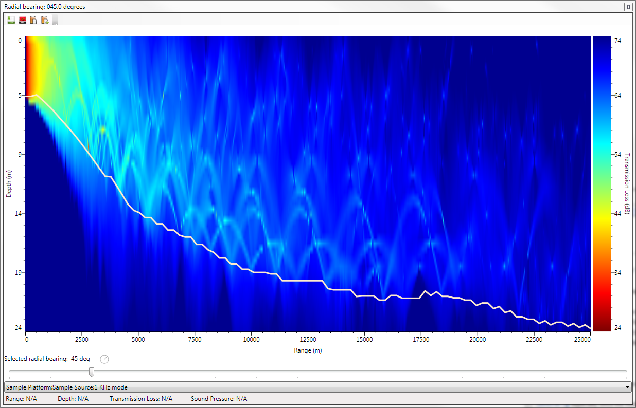

A sound sources’ transmission loss is calculated as one two-dimensional plane every 22.5 degrees rotating about the latitude and longitude of the analysis point. In the plot above, the white line represents the bathymetric profile along that radian: any point below the line is sediment. Any point above it is water. The acoustic reflectivity of the water at the surface is an indirect function of the wind speed at that location. Sound transmission into sediment is similarly a consequence of different sediment types’ ability to absorb or reflect sound.

Moving the mouse inside the plotted radial will update the status bar at the bottom of the window to display the current range from the source, depth in the water column, and what the transmission loss and sound pressure level are at that location, if there are any available. With certain sources, it is possible for no sound wave to pass through a given location of simulated ocean; in this case, the display will register N/A.

The color bar on the right hand side of the window is fully interactive. By default, its bounds are set to the global minimum and maximum of all radials in the selected mode’s transmission loss. However, double-clicking on the color bar will switch to the local minimum and maximum values of the selected radial. In this way, the relative loudness of the source at a given position may be more easily conceived. In addition, the color bar range may be manually adjusted by clicking and dragging to expose the fine structure of each radial, if desired.

The color bar will dynamically adjust to the global minimum and maximum of the *currently calculated* radials. If an analysis point or TL is visualized before all radials have completed calculation, the color bar will readjust as new radials finish calculation.

A toolbar at the top of the control allows the displayed transmission loss to be saved either to CSV or an image file, as well as copied to the clipboard.

If an analysis point is being displayed, a drop-down menu will be at the bottom of the control, from which may be selected all available modes for that analysis point.

If a transmission loss is displayed, the menu will be hidden.

If the external Transmission Loss Viewer is launched from the windows Start Menu, a tree view of all scenarios and locations stored on disc will be presented instead.

# Conclusion

This concludes the ESME Workbench 2012 Demo Quick Start Guide.

This demo was intended to showcase the acoustic modeling features of ESME Workbench. Workbench is under rapid development, and in the upcoming two months the following features are planned:

* Re-integration with 3MB; the ability to add animal populations to Scenarios
* Full mobility of platforms with defined movement patterns.
* Acoustic exposure simulation
* Reporting and summary statistics.

More new features scheduled for inclusion:

* Addition of new environmental databases
* Addition of RAM, an acoustic simulator for low-frequency sources.